NAME: PRIYADHARSHINI N

REG.NO: 731621121043

EMAIL ID: [priyanarayanan2603@gmail.com](mailto:priyanarayanan2603@gmail.com)

SQL LAB ASSIGNMENT-02

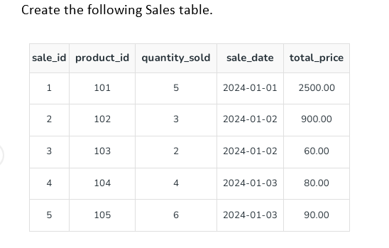

CREATE TABLE:

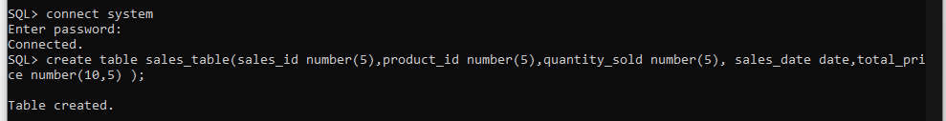

INSERT TABLE:

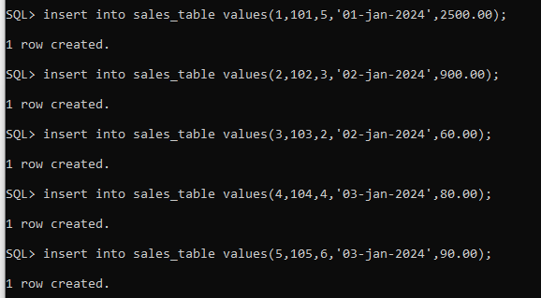

1. **Retrieve all columns from the Sales table.**

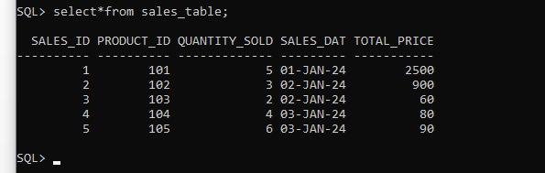

1. **Retrieve sale_id and quantity_sold from sales table.**

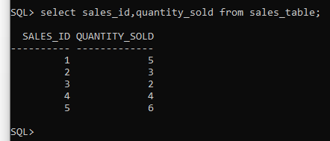

### Retrieve the sale_id and sale_date from the Sales table.

### 

### Filter the Sales table to show only sales with a total_price greater than $100.

### 

### Retrieve the sale_id and total_price from the Sales table for sales made on January 3, 2024.

### 

### Retrieve the sale_id, product_id, and total_price from the Sales table for sales with a quantity_sold greater than 4.

### 

1. **Retrieve all columns from the Sales table those sale_id are 1, 3 & 5.**

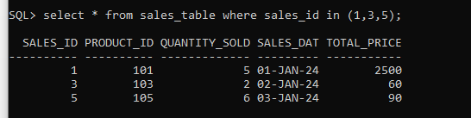

1. **Retrieve all columns from the Sales table those total_price between 90 and 1000.**

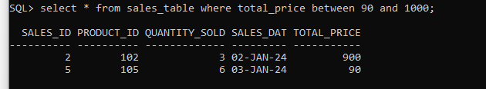

1. **Retrieve all columns from the Sales table those total_price not between 90 and 1000.**

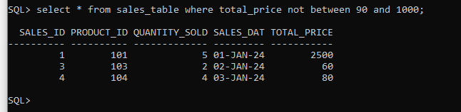

1. **Retrieve all columns from the Sales table those sale_id are not in 1, 3 & 5.**

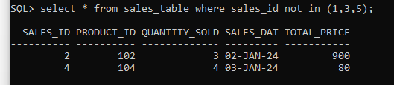

1. **Update total_price as 500 in the Sales table those sale_id are 1, 3 & 5.**

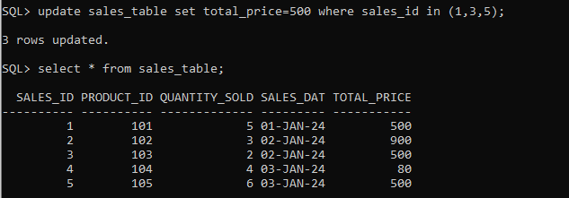

1. **delete from the Sales table those total_price not between 90 and 1000.**

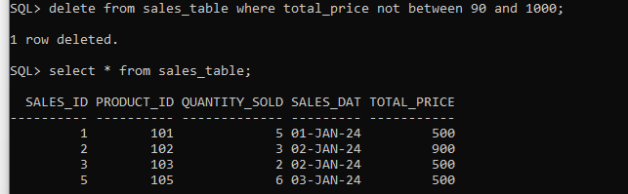

**13. Sort all the records using sale_id column in ascending order** 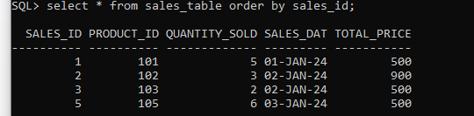

1. **Sort all the records using sale_id column in descending order.**

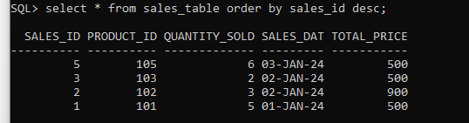

1. **Rename the sale_id column as sales_id;**

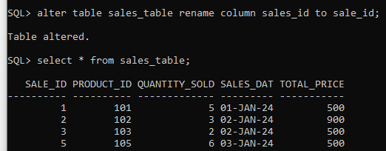

1. **Drop the column sales_id.**

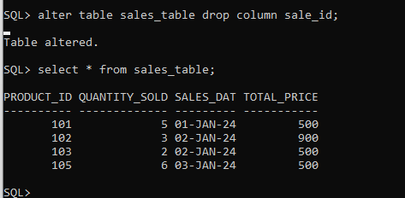

1. **Rename the table as tbl_sales.**

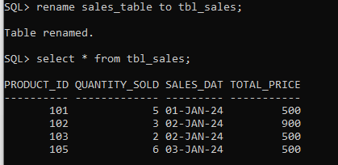

**18. Drop the table.**

